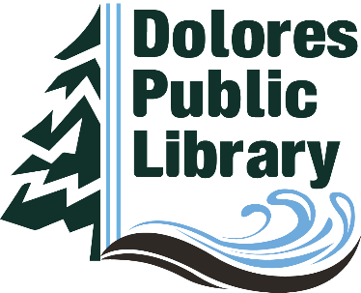

Dolores Public Library
Finance Committee
October 11, 2022 Agenda
4:00 p.m.

A. Call to Order
Acknowledge members and guests present

B Discussion and Action Items
1. Review of 1st Draft 2023 Budget
2. Discussion of Preliminary Certification of Valuation Report

C. Topics for next Finance Committee meeting
1. 2023 Budget

